**MWS Pod**

**Statement of work**

Index

1. Scope 1

1.1 Identification 1

1.2 System overview 2

1.3 Document overview 3

2. Requirements 3

2.1 Functional requirements 3

2.1 Performance requirements 4

2.2 Environment requirements 4

2.3 Interface requirements 4

3. Notes 5

3.1 Abbreviations 5

**History**

|  |  |  |  |
| --- | --- | --- | --- |
| **Date** | **Description** | **Name** | **Version** |
| 21-09-2010 | Initial document | kpi | 1.0 |

# Scope

## Identification

The system to which this document applies is a pod that can be attached to the F-16 combat aircraft using standard T-hooks spaced by 13 inches.

The dimensions and shape of the system shall be defined by manufacturer and shall be in compliance with the FP42f standard.

The pod has three compartments for chaff/flare magazines. Two compartments hold two magazines each and one compartment holds four magazines.

It houses an electronic control unit and has suspensions for power/data cable harness, connectors and six sensor units which covers all angles not shaded by the aircraft seen from the pod.

The manufacturer will identify the placement of the six sensors.

The system is able to keep the temperature of the MWS inside the pod below 70 degree Celsius.

The pod structure and attachments is able to withstand high g-forces and high temperatures especially on the front part and still be operational.

All requirements are verified by subcontractor.

## System overview

The pod is part of a self protection suite for the F-16 combat aircraft (see Figur 1) which protects the aircraft against missile attacks. The system is made up of 2 main systems which are:

* A cockpit control unit which keeps the state of the system handles communication and controls firing of the magazines.
* A pod which incorporates eight magazines and a missile warning system (MWS) consisting of six sensor and an electronic control unit.

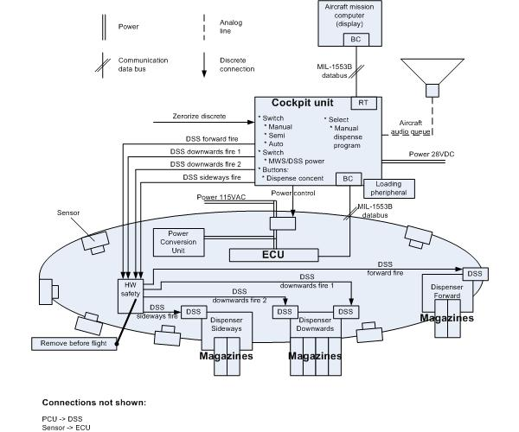

Figur

Missiles are detected by the MWS and information is sent to the cockpit control unit, which is able to react by dispensing flares and chaffs according to the program chosen.

The system has a number of different users depending on what is done and where:

On ground the system can be maintained by technicians that update SW and control the system

Ground personnel can mount the POD and when ready for takeoff, arm it.

The pilot uses the system, by choosing an appropriate program and depending on program chosen, consent dispense when missile attacks are detected.

After dispensing has happened maintenance is done again and the magazines are filled again with flares and chaffs.

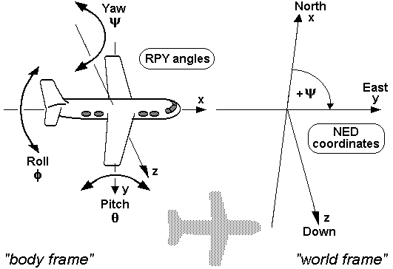

Figur . The figure illustrates how angles are represented relative to the aircraft. Forward, Left and down is positive. RPY: Roll, Pitch, Yaw; NED: North, East, Down.

## Document overview

This document describes the requirements for a pod that can be attached to the F-16 combat aircraft using standard T-hooks spaced by 13 inches.

# Referenced documents

## Requirements sources

|  |  |  |
| --- | --- | --- |
| Ref-1 | Therma case.pdf | Version 1 |

## Standards

|  |  |
| --- | --- |
| **Standard** | **Description** |
| DM30p | NATO dispenser magazine type contains the complete details about the magazines physical constructions and interface, |
| FP42f | MIL standard 1600-2-9 v12.45 - F-16 POD standard contains complete specification about requirements for POD manufacturing, including size, weight, material, shape, etc. |
| FE16d | F-16 EW standard contains the requirements and test procedures required to have a new system approved on an F-16. |
| PM11b | F-16 POD mounting standard includes specifications on how a POD shall safely be mounted to an F-16 aircraft. |

# Requirements

## Functional requirements

|  |  |
| --- | --- |
| UFR-1 | The pod shall have Three compartments for dispenser magazines. |
| UFR-2 | The pod shall have one compartment for two magazines facing forward.  Ψ = 15⁰ φ = 15⁰ θ = 15⁰. Se figure 1. |
| UFR-3 | The pod shall have one compartment for four magazines facing sideward.  Ψ = 90⁰ φ = 15⁰. Se figure 1. |
| UFR-4 | The pod shall have one compartment for two magazines facing downwards.  φ = 90⁰ θ = 90⁰. Se figure 1. |
| UFR-5 | The dimensions of the pod shall comply to the standard FP42f |
| UFR-6 | All electrical connections shall be accessible from the outside to ease the attachment of the pod to the aircraft and for testing on ground when not attached. |
| UFR-7 | If active cooling or other power consuming entities other than the contractor supplied MWS and DDSs are required, the total power consumption of these shall not exceed 300W at 115VAC 400Hz. |
| UFR-8 | The POD shall comply with all F-16 requirements for aerodynamics and radar reflections as specified by the F-16 POD standard *FP42f*. |
| UFR-9 | The ECU shall perform the built in test that is supported by this Government Furnished Equipment (*GFE*). |
| UFR-10 | The ECU shall report the status information available for this Government Furnished Equipment (*GFE*). |
| UFR-11 | The POD shall supply the status of the following LRUs:   * The Sensors * The ECU   INFO: The Magazines and DSS are not seen as LRUs and also do not have status reporting capabilities.  INFO: It is assumed that the ECU has the ability to deliver this information. |
| UFR-12 | The status reported by the POD as a whole shall be:   1. POD internal temperature 2. ECU operational status (OK, ERROR)   INFO: It is assumed that the ECU has the ability to deliver this information.  INFO: It is assumed that the ECU has a temperature sensor inside the POD and is able to deliver its reading on the data bus. |

## Performance requirements

|  |  |
| --- | --- |
| PR-1 | The pod structure shall be without any failures after being exposed to a steady state acceleration of 5g fore. |
| PR-2 | The pod structure shall be without any failures after being exposed to a steady state acceleration of 2.5g aft. |
| PR-3 | The pod structure shall be without any failures after being exposed to a steady state acceleration of 25g up. |
| PR-4 | The pod structure shall be without any failures after being exposed to a steady state acceleration of 11g down. |
| PR-5 | The six sensors shall be located to cover all angles which are not shaded by the aircraft. |

## Environment requirements

|  |  |
| --- | --- |
| ER-1 | The pod structure shall be operational at temperatures of 95 ̊C on the outer skin for 25 minutes and 102 ̊C on the leading edge for 25 minutes. |
| ER-2 | The pod structure shall be operational at temperatures of 134 ̊C on the outer skin for 3 minutes and of 151 ̊C on the leading edge for 3 minutes. |
| ER-3 | The system shall be able to keep the MWS inside the pod below 70⁰ C. |

## Interface requirements

|  |  |
| --- | --- |
| IR-1 | The attachment to the aircraft shall comply to standard PM11b. |
| IR-2 | The pod shall provide a EPC17d connector for 115VAC/400Hz power. |
| IR-3 | The pod shall provide a EDC29b connector for the data connection. |
| IR-4 | The pod shall provide a EDWC7f connector for discrete wires. |
| IR-5 | The dispenser magazine compartments shall interface to the magazines according to standard DM30p. |
| IR-6 | The cockpit control unit shall support 28VDC supply voltage. |
| IR-7 | Power consumption of the pod shall not exceed 700W. |
| IR-8 | The POD shall be able to run on 115VAC 400Hz. |
| IR-9 | The system shall be able to supply the GEF (MWS) with maximum 85W from a 28VDC power source and a maximum of 100W from an 115VAC 400Hz power source. |
| IR-10 | The system shall be able to supply power required to ignite a payload (126W) for a period of up to 20ms. |

# Safety requirements.

|  |  |
| --- | --- |
| **REQ ID** | **Requirement** |
| SR-1 | The POD shall include a safety pin that prevents the dispenser from firing. |
| SR-2 | The POD safety pin shall be clearly labelled and accessible by aircraft maintenance crew as specified by the aircraft maintenance manual *AMM32f*. |

# Weight

|  |  |
| --- | --- |
| **REQ ID** | **Requirement** |
| WR-1 | The total weight of POD shall not exceed 270 kg. |
| WR-2 | The POD shall be able to support an 18.2kg MWS |

# Mounting

|  |  |
| --- | --- |
| **REQ ID** | **Requirement** |
| MR-1 | The pod shall be mounted on the aircraft wing with standard T-hooks spaced by 13 inches. |
| MR-2 | The pod shall be mounted on the left-hand wing. |
| MR-3 | The POD shall support standard NATO dispenser magazines type DM30p. |

# Notes

## Abbreviations

|  |  |
| --- | --- |
| SOW | Statement of work |
| UFR | User Functional REQ |
| PR | Performance REQ |
| IR | Interface REQ |
| ER | Environment REQ |
| MR | Mounting REQ |
| WR | Weight REQ |
| SR | Safety REQ |
| MWS | Missile Warning System |